**COHERENCE THERAPY AND MEMORY RECONSOLIDATION**

**(for your work with Individuals, Couples and Families )**

LONDON OCTOBER 10th & 11TH 2020  
WITH SARA K. BRIDGES PhD  
**DEVELOP YOUR UNDERSTANDING AND EXPAND YOUR SKILLBASE**

Join workshop presenter **Dr Sara K. Bridges** on October 10th and 11th on her third visit to London, where you will learn more about the ground-breaking principles underpinning **Coherence Therapy** ([www.CoherenceTherapy.org](http://www.CoherenceTherapy.org)) and **Memory Reconsolidation - The Brain’s Innate Neural Process For Enabling Lasting Behavioural Change.**

In this intimate intensive workshop (PLACES LIMITED) you will have the opportunity to deepen your understanding of how **Coherence Therapy** dispels a wide range of problems and symptoms by dissolving their emotional roots. Additionally, you will be introduced to different experiential methods to help further the practice of **Coherence Therapy** with Individuals, Couples and Families.

In accordance with the principles of **Memory Reconsolidation**, **Coherence Therapy** involves using a guided process for accurately finding the specific emotional implicit constructs and schemas maintaining a symptom, followed by a guided process of transformational change that nullifies those schemas, releasing their powerful grip and ending symptom production.

In this two-day intensive skills-building workshop the emphasis will be on providing opportunities for you to develop and hone your skills doing your own ‘real’ sessions in small groups. You will be coached by Sara offering live, in-the-moment feedback, as together with colleagues you develop your competencies in working with the discovery, integration and transformation phases of **Coherence Therapy**. Further, case examples, video and discussion of **Coherence Therapy** will be woven into this 2 day workshop.

Participants in this workshop need to evidence familiarity with and experience of working with the principles of **Coherence** **Therapy** with clients and be familiar with ‘**Coherence Therapy Practice** **Manual’** or *‘****Unlocking the Emotional Brain’*** and or *‘****Depth* *Oriented Brief Therapy’***.

**COHERENCE THERAPY AND MEMORY RECONSOLIDATION (for your work with Individuals, Couples and Families)**  
LONDON OCTOBER 10TH & 11TH 2020   
WITH SARA K. BRIDGES PhD  
**DEVELOP YOUR UNDERSTANDING AND EXPAND YOUR SKILLBASE**

**DATES: WORKSHOP INTENSIVE – October 10th and 118h 2020 (9am – 5pm)**

**COST: October 10th and 11th 2020 £395.00**

**VENUE: The Guild of Psychotherapists, 47 Nelson Square, London SE1 0QA**

**BOOKING: Please complete the attached workshop booking form and return it by e-mail to  
 Ros Draper at** [**rosdraper@crisalida.cu.uk**](mailto:rosdraper@crisalida.cu.uk)

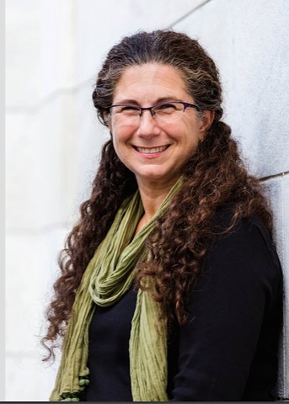

**Dr Sara K. Bridges** is the co-director of the Coherence Psychology Institute and a certified trainer and supervisor of Coherence Therapy. Dr Bridges is also the Director of Training and an associate professor of Counselling Psychology at the University of Memphis. She is a recipient of the distinguished Teaching Award for the University of Memphis and an active scholar of constructivism and sexuality. Dr Bridges has co-edited the five volume *Studies in the Meaning* series. She is a past president of both the Constructivist Psychology Network and the Society of Humanistic Psychology (Division 32 of the American Psychological Association). Dr Bridges is also a licensed psychologist in Tennessee and New York with a distance based private practice.

**DATES: SUPERVISION DAY – October 12th 2020 (9am – 5pm)**

**COST: October 12th $120.00 per hour payable direct to Sara by 1st October 2020**

**VENUE: The Guild of Psychotherapists, 47 Nelson Square, London SE1 0QA**

**BOOKING: If you are interested in booking one to one or group supervision time with Sara please e-mail Ros Draper at** [**rosdraper@crisalida.co.uk**](mailto:rosdraper@crisalida.co.uk)stating your preferred time/s and whether you wish to book one hour one to one supervision or opt for a three hour group supervision with two or three colleagues. We will get back to you as soon as possible after the closing date: September 1ST 2020

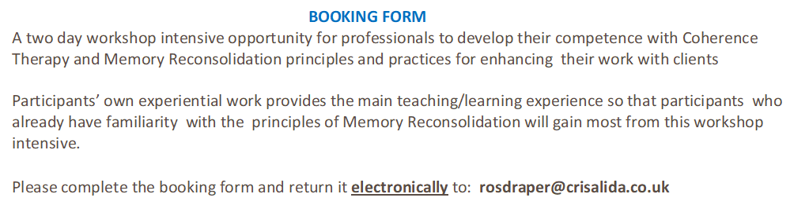

|  |  |
| --- | --- |
| **Workshop Dates and Fees**  **9.00 am to 5.00 pm daily**  **ONE HOUR LUNCH BREAK**  **TEAS, COFFEES, JUICES,  WATER  and SNACKS AVAILABLE ON SITE** | **Workshop Intensive October 10thth and 11th 2010   £395.00**□ |
| **NAME    (please print)**  **PROFESSIONAL QUALIFICATION** |  |
| **DETAILS OF ANY PREVIOUS EXPERIENCE WITH COHERENCE THERAPY  AND WORKSHOPS ATTENDED**  **(please print)** | **WORKSHOP TITLE         DATE/S ATTENDED           VENUE** |
| **LAND ADDRESS**  **(please print)** |  |
| **CONTACT TELEPHONE NO.** |  |
| **EMAIL ADDRESS**  **(please print)** |  |
| **Payment Method** | □ By cheque payable to CRISALIDA LIMITED and sent to  37 Lower    Wardown, Petersfield, Hampshire, GU31 4PA  □ By bank transfer (payment details on **LOGISTICS** page below) |
| **Receipt - sent electronically** | □ Yes, I would like a receipt sent electronically: |

**Signature:                       Date:**

**MEMORY RECONSOLIDATION AND COHERENCE THERAPY**   
LONDON OCTOBER 10TH & 11TH 2020   
WITH SARA K. BRIDGES PhD

**DEEPEN YOUR UNDERSTANDING & EXPAND YOUR SKILLBASE**

SE

**LOGISTICS**

**PAYMENT METHODS**

There are two payment methods available:-

**BANK TRANSFER**   – To make payment by bank transfer, please use the following account details using your name as the reference:-

Bank:            **HSBC**

Address:            **Market Square, Petersfield, Hampshire, GU32 3HQ**

Account Name:    **Crisalida Limited**

Account Number:    **71427555**

Sort Code:        **40-36-16**

BIC/SWIFT CODE:    **HBUKGB4149A**

IBAN:            **GB03HBUK40361671427563**

**CHEQUE -** Cheques are to be made out to **CRISALIDA LIMITED** and sent to **37 LOWER WARDOWN, PETERSFIELD, HAMPSHIRE, GU31 4PA**

**CANCELLATION POLICY -** Payment is fully refundable (less £60.00 administration fee) if a cancellation is made in writing and received on or before **August 1st**. Regrettably after **August 1st 2020** due to speakers’ travel costs and administration arrangements refunds are not available under any circumstances.

**There is £60.00 administration fee for all cancellations.**

**PLEASE NOTE YOUR BOOKING IS NOT CONFIRMED UNTIL PAYMENT IS RECEIVED IN FULL**

VENUE            The workshop will take place at the following address:

**The Guild of Psychotherapists**

**47 Nelson Square**

**London**

**SE1 0QA**

**CERTIFICATES OF ATTENDANCE (12 hours credit) will be available for all participants at the end of the workshop**

**WHAT TO BRING**

**Clothing –** Comfortable, relaxed clothing isall that’s needed.

**Refreshments** - Tea/coffee/juice fruit and snacks will be provided throughout the workshop.  We would encourage you to bring water with you to keep yourself hydrated during the two days.  There are a number of convenience shops and choice of restaurants close by for lunch but you are welcome to bring snacks and/or a packed lunch with you.

**Stationery** – All you will need is a notepad and pen.  You will be provided with all other materials.

***WE LOOK FORWARD TO SEEING YOU THERE!!***

**MEMORY RECONSOLIDATION AND COHERENCE THERAPY**   
LONDON OCTOBER 10TH & 11TH 2020   
WITH SARA K. BRIDGES PhD

**DEEPEN YOUR UNDERSTANDING & EXPAND YOUR SKILLBASE**

SE